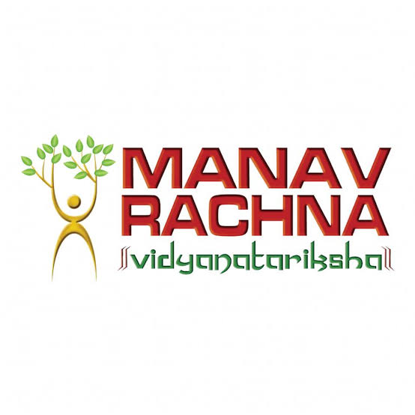

***Summer Internship Report***

***On***

***Graphic Design***

***At***

***InAmigos Foundation***

***Submitted to***

***Manav Rachna International Institute of Research and Studies***

***School Of Computer Applications***

*In Partial fulfilment of the requirements of Bachelors in Computer application*

Submitted By (Name, Roll Number)

**Ankur Gautam, 24/SCA/BCA/097**

**2nd Semester**

Under The Supervision Of

**DR. SAVITA**



**Manav Rachna International Institute of Research and Studies**

**School Of Computer Applications**

**SUPERVISOR’S RECOMMENDATION**

I hereby recommend that the report prepared under my supervision by Ankur Gautam entitled “Graphic Designing” at InAmigos Foundation in partial fulfilment of the requirements for the degree of Bachelor in Computer Application (BCA) be processed for evaluation. This report is satisfactory and is an original work done by him to process for the future evaluation.

………………………..

**Dr. Savita**

Supervisor

Department of BCA



**Letter Of Approval**

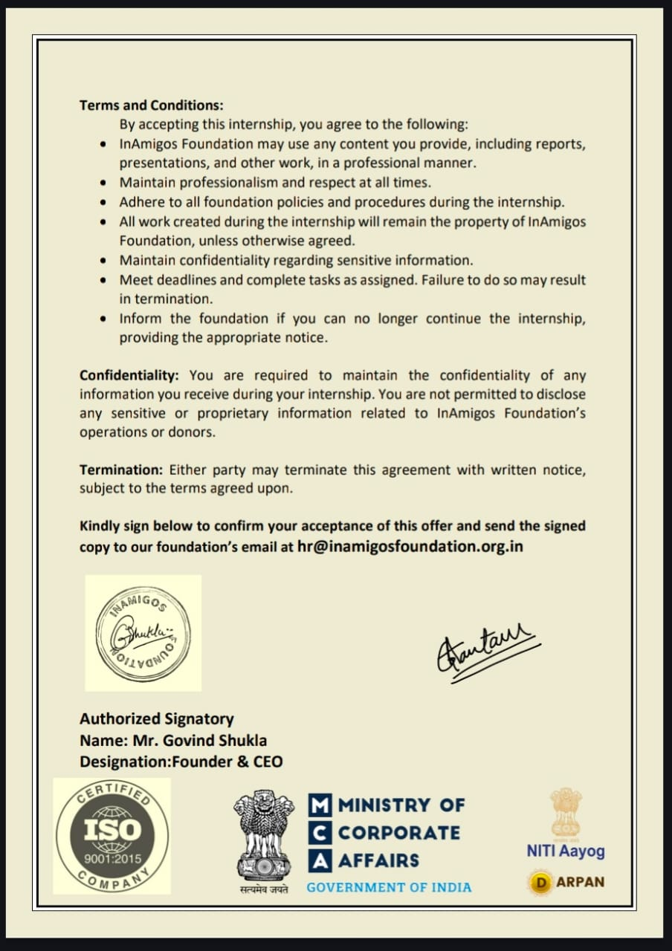

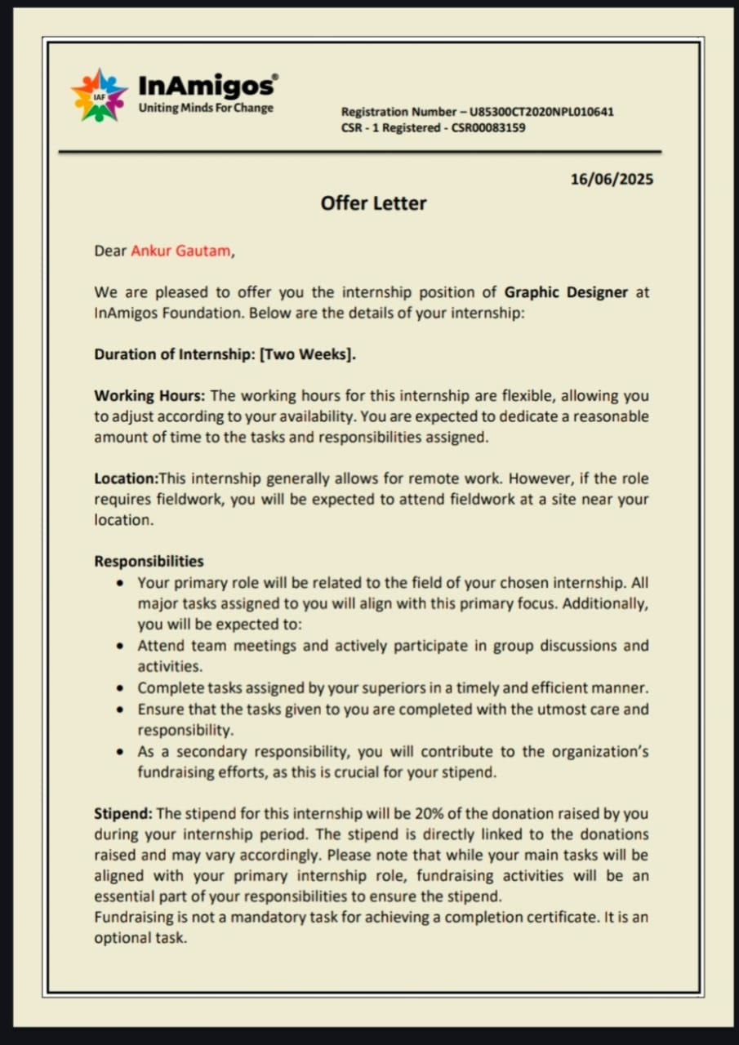



**APPROVAL OF REPORT**

This internship report has approved and recommended to the Department of Computer Application for acceptance of report entitled "Graphic Designing" submitted by Ankur Gautam in partial fulfillment for the degree of Bachelor of Science in Computer Application (BCA). Institute of Science and Information Technology. Tribhuvan University.

|  |  |
| --- | --- |
| ………………………..  **Dr.**  **Dean**  **School of Computer Applications** | ………………………..  **Dr. Suhail Qureshi**  **HOD**  **School of Computer Application** |
| ………………………..  **Dr. Kavita Arora**  **Program Coordinator**  **School of Computer Applications** | ………………………..  **Dr. Savita**  **Supervisor**  **School of Computer Applications** |



**CERTIFICATE OF COMPLETION**

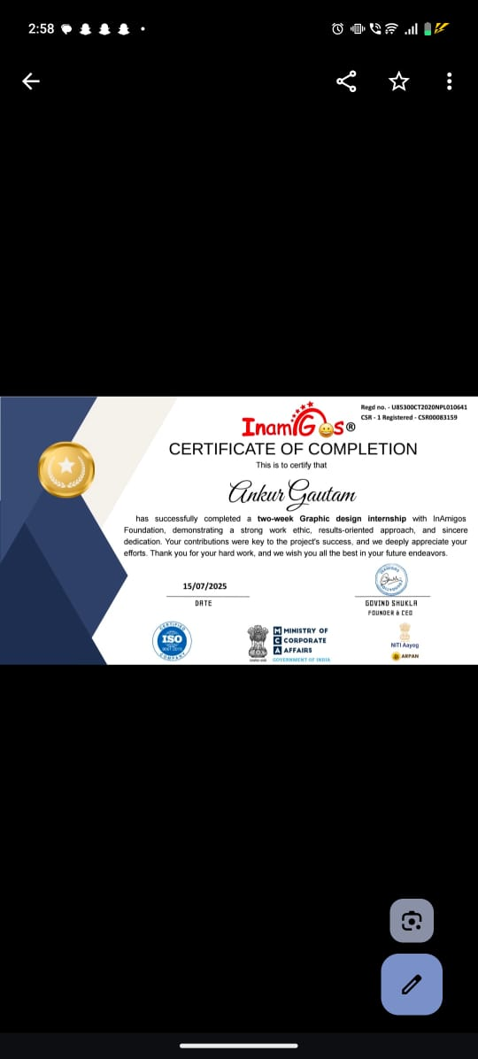



**LETTER OF RECOMMENDATION**

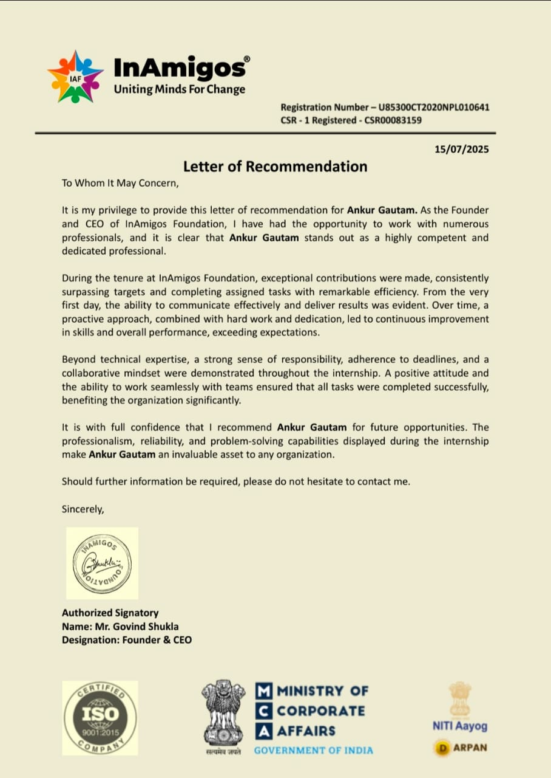



**CERTIFICATE OF APPRECIATION**

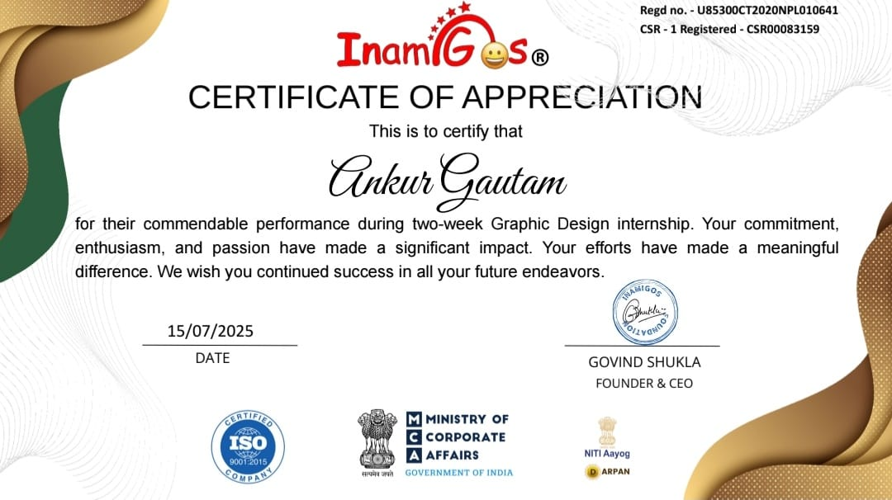

**ACKNOWLEDGEMENT**

I would like to express my deepest gratitude to everyone who made my internship at Purple Inc. a valuable and enriching experience.

Firstly. I would like to thank Manav Rachna International Institute of Research and Studies for providing me with this opportunity to gain practical experience in the field of graphic design. The college's support and encouragement have been instrumental in my professional development.

I would also like thanks to my supervisor, Dr. Savita, for his constant support, guidance, and encouragement throughout the internship.

I am also deeply thankful to my mentor, Ms. Deepaxi Rajrahi, for his patience, mentorship, and valuable feedback. His dedication to teaching and his passion for design have inspired me greatly and helped me enhance my creative abilities.

Additionally, I would like to thank the faculty and staff for providing a conducive learning environment and the necessary resources to facilitate my internship experience.

Lastly, I am grateful to my family, friends, and colleagues for their support and encouragement throughout this journey.

Sincerely.

Ankur Gautam

**ABSTRACT**

This report is intended to provide an acknowledgement of my experience as a graphics design intern at InAmigos Foundation.The report will detail my responsibilities and tasks, as well as my overall experience and what I gained from the internship.

During my internship at InAmigos Foundation, my main responsibilities included creating graphics for social media, logos designing, and editing images. I was also responsible for contributing to brainstorming sessions for upcoming campaigns and projects, and working with other team members to develop concepts and ideas.

Throughout my internship, I had the opportunity to work on a variety of projects, including designing promotional materials, creating social media graphics, and designing thumbnails for YouTube. I was able to apply the design principles and techniques I learned in school to real-world situations and develop my skills in using design software such as Adobe Photoshop, Illustrator and Canva.

Overall, my experience as a graphics design intern at Purple Inc was extremely positive. The team members I worked with were friendly, supportive, and knowledgeable.

Overall, my graphics design internship at Purple Inc was an extremely positive experience. I gained valuable skills, knowledge, and experience that will be beneficial in my future career. I would like to thank the team members at Purple Inc for providing me with this opportunity and for their support throughout my internship.

During the internship, the author worked on a variety of projects and assignments, such as developing logos, retouching photos to meet customer specifications, and producing eye-catching graphics for several social media platforms.

The author was able to operate in a collaborative and creative atmosphere that was upbeat, motivating, and supportive. The author's practical knowledge and skill set were improved by the opportunity to engage with and learn from a variety of industry specialists.

Through the internship, the author was able to acquire important soft skills including time management, cooperation, and communication.

Keywords: Communication. Time Management, Cooperation, Proper Implementation of Design Principles

**Table Of Content**

1. SUPERVISOR'S RECOMMENDATION
2. INTERNSHIP CERTIFICATION
3. LETTER OF APPROVAL
4. COMPLETION CERTFICATE
5. CERTIFICATE OF APPRECIATION
6. ACKNOWLEDGEMENT
7. ABSTRACT

CHAPTER 1 INTRODUCTION

1.1 Introduction

1.2 Problem Statement

1.3 Objectives

1.4 Scope

7.2 Limitation

7.3 Report Organization

Chapter 2 Introduction to Organization

2.1. Organization Details

2.2. Organizational Hierarchy.

2.3. Working Domains of Organization

2.4. Description of Intern Department/Unit.

Chapter 3 Background Study and Related Works

3.1. Background Study

3.2. Literature Review.

Chapter 4 Internship Activities.

4.1. Roles and Responsibilities.

4.2. Weekly log

4.3. Description of the Project(s) Involved During Interns

4.4. Tasks/Activities Performed.

Chapter 5 Conclusion and Learning Outcomes

5.1. Learning Outcome.

5.2. Conclusion.

References

Appendices

**CHAPTER 1**

**INTRODUCTION**

**1.1 Introduction**

A graphic designer is a professional who creates visual concepts, using computer software or by hand, to communicate ideas that inspire, inform, or captivate consumers. They develop the overall layout and design of a wide range of products, including advertisements, brochures, magazines, logos, websites, product packaging, and more. Graphic designers use typography, color, imagery, and other elements to create visually appealing and effective designs that meet the specific needs of their clients.

To become a successful graphic designer, one must possess strong artistic skills, creativity, and a keen eye for detail. They should also have excellent communication skills, as they will be required to work with clients and colleagues throughout the design process. Additionally, graphic designers must be proficient in the use of design software, such as Adobe Photoshop, Illustrator, and InDesign.

In today's digital age, graphic designers are in high demand, and their skills are essential for businesses and organizations to effectively market themselves and communicate their message to their target audience. As a result, the field of graphic design offers a wide range of exciting career opportunities for those who have a passion for art and design.

**1.2 Problem Statement**

As a graphic designer, the problem statement can vary depending on the specific projector task at hand. However, in general, the problem statement for a graphic designer could be:

* Modernization: Update the visual style to reflect current design trends while maintaining a timeless quality.
* Brand Identity: Ensure the logo aligns with the company's eco-friendly and innovative ethos.
* Recognition: Design a logo that is distinctive and memorable, fostering strong brand recognition.
* Simplicity: Maintain a clean and simple design that is easy to reproduce and does not lose detail at smaller sizes.

**1.3 Objectives**

The objectives of a graphic designer can vary depending on the industry and the specific project they are working on, but generally, their main objectives are:

* To communicate visually: Graphic designers use various elements of design such as color, typography, images, and layout to create visual communication that effectively conveys a message to a specific audience.
* To solve problems creatively: Graphic designers use their creativity and problem-solving skills to develop solutions for various design challenges, such as creating a logo, designing a website, or developing an advertising campaign.
* To create a cohesive brand image: Graphic designers help organizations develop a consistent brand image by creating visual elements that represent their brand, such as logos, business cards, and advertising materials.

Overall, a graphic designer's main objective is to create visually compelling and effective communication that resonates with their audience and achieves their client's goals.

**1.4 Scope**

1 The scope of a graphic designer's work can be broad, as they may work in various industries and on a wide range of projects. Some of the areas in which graphic designers may work include:

2 Advertising: Creating visual communication for print and digital ads, billboards, and other promotional materials.

3 Branding: Developing logos, color schemes, and other visual elements that represent a brand and convey its message.

4 Print design: Creating layouts and designs for brochures, packaging, magazines, and other printed materials.

5 Motion graphics: Designing animation, video graphics, and other moving visual content.

6 Environmental designs: Creating designs for physical spaces, such as store displays, trade show exhibits, and signage.

**7.2 Limitation**

While there is a broad scope to the work of a graphic designer, there are also some limitations. For example:

Creative limitations: Graphic designers must work within the constraints of their clients' budgets, timelines, and branding guidelines, which can limit their creativity and flexibility.

Technical limitations: The technology and software available to graphic designers may limit the scope of their work, as not all designs may be possible with current tools and techniques.

Language limitations: Graphic designers must be aware of cultural and language differences when designing for a global audience, which can limit the scope of their work in some cases,

Legal limitations: Graphic designers must also be aware of copyright laws and intellectual property rights, which can limit the use of certain images or materials in their designs.

In summary, the scope of a graphic designer's work can be vast and varied, but there are also some limitations that must be considered in order to create effective and appropriate designs.

**7.3. Report Organization**

The internship report for the Graphic Design project is divided into 5 chapters. Each chapter outlines the development of the project with its vision and background.

The first chapter provides an introduction to the internship project along with the problem statement, objectives, and scope and limitations of the project.

The second chapter presents an introduction to the organization, its structure, and the working domains. It also includes a description of the role of the intern in the organization.

The third chapter includes the background study of the project and literature review of the similar projects with similar theories and results. It highlights the various design principles, techniques, and tools used during the internship.

The fourth chapter consists of the roles and responsibilities acquired during the internship period along with the list of technical activities performed. It also provides the descriptionof the projects involved with tasks and activities performed.

The final chapter is the conclusion section which includes the learning outcomes from the internship. It reflects on the experiences gained and the skills developed during the internship and how they can be applied in future endeavors.

**Chapter 2**

**Introduction to Organization**

**2.1. Organization Details**

InAmigos Foundation is a youth-led nonprofit organization dedicated to empowering individuals through skill development, internships, and educational initiatives. The foundation operates with the mission of nurturing talents across India, especially in underprivileged communities, by providing equal opportunities to grow and lead.

InAmigos Foundation offers a wide array of programs including graphic design training, digital literacy, social media internships, content creation, and community development initiatives. These programs are tailored to enhance employability and foster innovation among students and young professionals.

The foundation strives to build a stronger society by bridging the gap between learning and earning, with a focus on creating impact without relying on foreign funding.

**2.2. Organizational Hierarchy**

Hierarchy of InAmigos Foundation in the creative & internship departments is as follows:

Program Director: Oversees all foundation programs, including training and internships, and ensures strategic alignment with the foundation's goals.

Project Manager: Responsible for supervising daily operations, coordinating with team leaders, and monitoring outcomes of ongoing projects.

Team Leader: Leads a group of interns or volunteers, assigns tasks, provides feedback, and ensures timely project delivery.

Interns/Volunteers: The driving force behind projects who actively participate in designing, content creation, research, and community outreach under the guidance of their team leaders are responsible for creating basic designs.

Project Manager: The person responsible for overseeing the entire design project.They work with the creative director, art director, and designers to ensure that the project is completed on time and within budget.

Marketing Manager: The person responsible for developing and implementing marketing strategies to promote the designs created by the organization.

**2.3. Working Domains of Organization**

Graphic design is a broad field that encompasses a variety of domains, each with its unique focus, skills, and challenges. Some common domains of Purple Inc., in graphic designing include:

* Branding and identity design: This domain involves creating visual systems and elements that represent a company, product, or service. Branding and identity design includes logos, color palettes, typography, and other visual elements that convey the brand's personality, values, and unique selling points.
* Print design: This domain involves designing printed materials such as brochures, flyers, posters, packaging, and business cards. Print design requires a good understanding of layout, typography, color theory, and printing techniques.
* Digital design: This domain involves designing digital interfaces and experiences such as websites, social media graphics, and digital advertising.
* Illustration and iconography: This domain involves creating custom illustrations and icons that communicate complex ideas, simplify information, or enhance the visual appeal of a design. Illustration and iconography require a good understanding of drawing, composition, color, and visual storytelling.
* Motion graphics and animation: This domain involves creating moving visuals that engage and entertain audiences, such as animated logos, explainer videos, and social media ads.

**2.4. Description of Intern Department/Unit**

As an intern in the Graphic Design Department/Unit, my primary responsibility is to support the creative team in producing high-quality visual content for various marketing materials. This includes designing logos, brochures, social media posts, and other promotional materials.

I work closely with senior designers and project managers to ensure that my work aligns with the company's branding and messaging. I am responsible for tasks such as conducting research, brainstorming ideas, thumbnail designs, and creating digitalmock-ups. I am also open to receiving constructive feedback from the team to improve my work.

Through my internship, I am gaining practical experience in the field of graphic design and learning the latest design tools and techniques. I am also developing my problem-solving and communication skills by collaborating with other departments and working on real-world projects.

Overall, my role in the Intern Department in graphic design is critical to the success of the creative team, and I am excited to contribute my skills and learn from the experienced professionals in the company.

**Chapter 3**

**Background Study and Related Works**

**3.1. Background Study**

Graphic design is the practice of creating visual content to communicate messages to a specific audience. The following are some fundamental theories, general concepts, and terminologies related to graphic design:

* Composition: The arrangement of elements in a design, including typography. images, and negative space.
* Color theory: The study of how color can be used to create different moods, emotions, and meanings in a design.
* Typography: The art and technique of arranging type to make written language legible, readable, and appealing when displayed.
* Grids: A system of horizontal and vertical lines that are used to structure content in a design.
* Contrasts: The juxtaposition of different elements in a design to create visual interest and hierarchy.
* Balance: The distribution of visual weight in a design to create a sense of equilibrium.
* Alignment: The arrangement of elements in a design along a common axis to create a sense of unity.
* Hierarchy: The arrangement of elements in a design to create a clear sense of order and importance.
* White space or negative space: The area around the design elements, which can help to create balance, contrast, and focus,
* Branding: The creation and management of a visual identity for a company or organization, including logos, color palettes, and typography.
* Visual hierarchy: The arrangement of design elements in order of importance or visual prominence, to guide the viewer's eye through the design.

These are just a few of the many concepts and terminologies that are relevant to graphic design.

**3.2. Literature Review**

Graphic design is a critical field that combines creativity, technology, and communication to convey messages and solve visual problems. Internships in graphic design serve as a bridge between academic learning and professional practice, offering hands-on experience and a deeper understanding of industry demands and expectations. This literature review explores the significance of graphic design internships, the skills developed through such experiences, and their impact on career development.

Internships provide an essential platform for students to transition from theoretical knowledge to practical application. According to Knemeyer (2004), has concluded, internships offer invaluable real-world experience, allowing interns to apply classroom knowledge in professional settings. This hands-on experience is crucial in graphic design, where practical skills in software tools and creative problem-solving are paramount.

Graphic design internships enable the development of both technical and soft skills.

Technical skills include proficiency in design software such as Adobe Photoshop, Illustrator, and Canva. These tools are industry standards, and mastery of them is essential for any aspiring graphic designer. The literature highlights that internships help students enhance their technical skills through practical application and feedback from experienced professionals (Chen, 2011).

Soft skills, such as time management, communication, and teamwork, are equally important. According to Gardner and Bartkus (2014), internships foster the development of these skills by placing students in collaborative environments where they must manage deadlines, communicate ideas, and work effectively with team members. These competencies are critical for success in the fast-paced and collaborative nature of the graphic design industry.

Internships provide students with a window into the graphic design industry's dynamics, challenges, and opportunities. They offer exposure to the workflow of professional design studios, client interactions, and project management. As Mourshed, Farrell, and Barton (2012) argue, such exposure is invaluable for understanding industry standards and expectations, which are often not fully covered in academic settings.

Furthermore, internships often lead to professional growth by helping students build portfolios that showcase their work to potential employers. A well-rounded portfolio, featuring a variety of projects completed during an internship, can significantly enhance a graduate's employability. Interns also gain mentorship from industry professionals, which can guide their career paths and provide valuable networking opportunities (Gault, Redington, & Schlager, 2000).

Despite the numerous benefits, internships are not without challenges. One common issue is the quality and structure of the internship program. According to Beck and Halim (2008), the learning outcomes of internships can vary widely depending on the support and opportunities provided by the host organization. Interns may also face the challenge of balancing their internship responsibilities with academic or personal commitments.

Additionally, unpaid internships are a contentious topic. While they provide experience, they can also limit access for students who cannot afford to work without compensation. This economic barrier can result in unequal opportunities and diversity in the graphic design field (Perlin, 2011).

Graphic design internships are a vital component of professional development, offering practical experience, skills enhancement, and industry insights that are crucial for career success. While challenges exist, particularly regarding the quality and accessibility of internships, the overall benefits for aspiring graphic designers are significant. As the graphic design industry continues to evolve, internships will remain a key pathway for students to bridge the gap between education and professional practice.

Internships in graphic design have been quite helpful in bridging the knowledge gap between my academic studies and professional experience. They have given me practical experience, enabling me to put my academic understanding to use in practical situations. I have honed critical technical abilities in industry-standard programs like Adobe Photoshop and Illustrator in addition to soft skills like communication, teamwork, and time management. Through these internships, I have been able to get significant insights into the dynamics, difficulties, and workflow of the industry, which has helped me construct a strong portfolio and secure professional mentorship.

**Chapter 4**

**Internship Activities**

4.1. Roles and Responsibilities

The roles and responsibilities of a graphic designer can vary depending on the specific joband industry, but some common tasks and expectations include:

* **Developing visual concepts:** Graphic designers are responsible for creating visual concepts that communicate ideas and messages effectively to the target audience. This involves researching and analyzing design trends, understanding the needs and preferences of the target audience, and creating unique and original design
* **Creating design elements:** Graphic designers create visual elements such as logos, typography, images, illustrations, and layouts. They use design software and tools to create these elements and may work with other team members, such as photographers or illustrators, to develop specific components of a project.
* **Collaborating with clients and team members:** Graphic designers often work closely with clients to understand their needs, goals, and preferences. They may also work collaboratively with other team members such as writers, marketers, and web developers to ensure that the overall project is cohesive and meets the client's objectives.
* **Following brand guidelines:** Many graphic design projects require the designer to follow strict brand guidelines, ensuring that the visual elements are consistent with the overall brand identity and message.
* **Managing project timelines and deadlines:** Graphic designers must be able to manage their time effectively to ensure that projects are completed on time and within budget. They may also be responsible for overseeing the work of other designers or contractors on the project,
* **Staying up-to-date with design trends:** Graphic designers must stay informed about current design trends and techniques. They must also be proficient in using design. software and tools, and be able to adapt quickly to new software and techniques as they emerge. Overall, the roles and responsibilities of a graphic designer involve using design skills and creativity to create visual content that effectively communicates a message or idea to a specific audience. They must be able to work collaboratively with others, manage their time effectively, and stay up-to-date with current design trends and tools.

4.2. Weekly Log

|  |  |
| --- | --- |
| **WEEKS** | **TASKS/ACTIVITIES** |
| 1 | Introduction to the team Overview of company design guidelines Setting up software and tools Learned the basic interface of design software, Basic graphic design tasks (e.g., social media posts, logo design) Showing senior designers Learned about how to get graphic design resources, Learned about graphic designing principles Create graphics for YouTube channel Attend design meetings, designs promotional materials (e.g., flyers, posters, pull-up banner), Feedback sessions with mentor Find out the mistakes and corrected accordingly Learned about inspiration websites, work on a small project independently ,Explore typography and color theory Design Balancing techniques Learn Basic of video editing software like Adobe premiere pro, after effect, learn about basic animations like (keyframe, masking),Learned how to use templates. |
| 2 | Created first logo animation video Lunched companies YouTube channel and started uploading videos Also created attractive thumbnail for videos, Mid-internship review and feedback session. Adjust goals and projects based on feedback. Researched design trends, Presentation preparation and design Worked on different client's project,  Finalize the major design project Mentor feedback and final adjustments, Internship wrap-up Final review and feedback. Work on a design project (e.g., campaign, brochure). |

4.3. Description of the Project(s) Involved During Interns

* **Branding and Identity:** This involves creating a visual identity for a company or product, including logos, colour schemes, typography, and other visual elements. This may also include developing brand guidelines to ensure consistency acrossall marketing materials.
* **Advertising:** Graphic designers may create print or digital advertisements for products or services, including billboards, magazine ads, and social media ads. They may also work on promotional materials such as flyers and brochures.
* **Packaging Design:** This involves designing the packaging for a product, including the layout, graphics, and other visual elements. Packaging design can be critical inhelping a product stand out on store shelves.
* **Publication Design:** Graphic designers may work on the design of books, magazines, or other publications, including layout, typography, and graphics.
* **Environmental Design:** Graphic designers may create signage or other graphics for physical spaces, such as retail stores or museums.
* **Motion Graphics:** This involves creating animated graphics or videos, often used in advertising or social media.

4.4. Tasks/Activities Performed

* Meeting with clients to understand their design needs and objectives.
* Researching and analysing design trends and styles to stay current with the industry.
* Creating visual concepts and designs using software such as Adobe Photoshop, Illustrator, or InDesign.
* Developing layouts and designs for various materials such as logos, brochures, advertisements, and packaging.
* Selecting colours, fonts, and other design elements to create a visually appealing product.
* Creating mock-ups and prototypes to present to clients or stakeholders for approval.

Collaborating with other professionals such as copywriters, photographers, and printers to ensure the design is cohesive and meets the client's needs.

* Preparing final designs for printing or publishing, and ensuring that they meet the necessary technical requirements.
* Managing multiple projects simultaneously and meeting deadlines.

**Chapter 5**

**Conclusion and Learning Outcomes**

5.1. Learning Outcome

During a graphic design internship. I learn and develop a variety of skills related to the field. These may include technical skills, such as using design software like Adobe Photoshop, Illustrator, and InDesign. Additionally, I got opportunity to improve my design skills, including colour theory, typography, composition, and layout.

In addition to technical and design skills, I gain an understanding of design principles and how to apply them to create effective visual communications. This can include branding, marketing collateral, and website design. I learn project management skills, including how to manage timelines, budgets, and communicate with clients.

Collaboration is an essential part of graphic design, and I got chance to work with other designers, developers, and stakeholders. This thing helps me develop my collaboration skills, which are important in design-related role.

Internships are an excellent way to gain professional experience and build my resume and portfolio. I'll have the opportunity to work in a real-world design environment and network with other professionals in the industry, including designers, art directors, and creative directors. Overall, a graphic design internship is an excellent opportunity to gain practical experience, develop my skills, and build professional connections that can help me to succeed in my future career.

For a graphics designing, a 2 weeks internship would likely involve working closely with a team of professionals to complete various design projects. This experience would allow me to develop and hone my design skills, as well as gain valuable insights into the industry and the specific challenges and opportunities it presents.

At the conclusion of the internship, it is important for me to reflect on my experiences and assess what I have learned. I consider how my skills and knowledge have grown, as well as any areas where I need further development. Additionally, it is important for me to solicit feedback from my supervisor or mentor, as well as my colleagues, in order to gain a better understanding of my strengths and weaknesses.

Overall, 2 weeks internship is valuable stepping stone for me, providing this experience and skills necessary to pursue my successful career in the field.

**References**

* **Canva. (2023), 10 Graphic Design Trends for 2024. Retrieved from** [**https://www.canva.com/learn/graphic-design-trends/**](https://www.canva.com/learn/graphic-design-trends/)
* **Adobe Systems Incorporated. (2023). Adobe Illustrator User Guide. Retrieved from** [**https://helpx.adobe.com/illustrator/user-guide.html**](https://helpx.adobe.com/illustrator/user-guide.html)
* **Adobe Creative Cloud Tutorials** [**Adobe Express**](https://new.express.adobe.com/?_branch_match_id=1464931906630987804&_branch_referrer=H4sIAAAAAAAAA8soKSkottLXT0zJT0otLkgsyi7ILy7RSywo0MvJzMvWd%2FcqcgpwCw13ckqyzy2zzS%2FJSC1SKyjKz83PTLE1NfV2sfAKDFerK0pNSy0qysxLj08qyi8vTi2ydU1JTwUAizlCK10AAAA%3D)
* **Behance. (2023). Portfolio Tips: How to Showcase Your Best Work. Retrieved from** [**https://www.behance.net/tips**](https://www.behance.net/tips)
* **Mourshed, M., Farrell, D., & Barton, D. (2012).**
* **"Education to employment: Designing a system that works." McKinsey & Company**

**APPENDICES**

During my internship. I was responsible for designing various marketing materials such as brochures, social media posts, and websites. I also managed social media accounts and created successful campaigns that resulted in increased engagement rates. I used tools such as Adobe Creative Suite and Canva to create visually appealing designs. Additionally, I regularly collaborated with the creative team and received feedback to improve my work. Overall, my work helped to support the company's branding and messaging goals. I have included some examples of my work below:

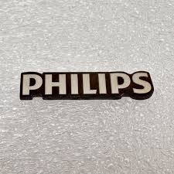



(Fig 1: Logos)



(Fig 2: Banner)



(Fig 3: Letter Head)



(Fig 4: Visiting Card)